
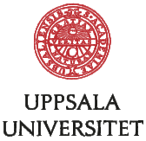
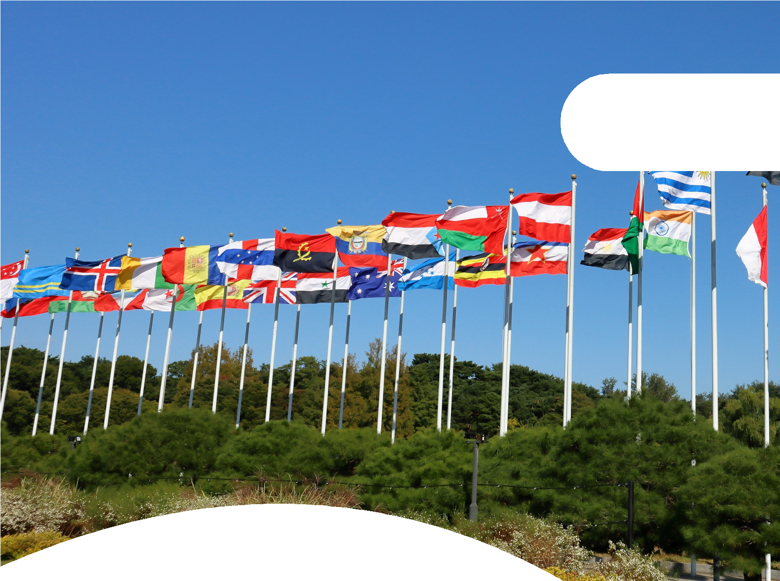

2025 Edition: Investment Arbitration Meets Economic Security

EUROPEAN - SOUTH ASIAN INVESTMENT ARBITRATION BOOTCAMP

18–22
August 2025

Rashtriya Raksha University, Gandhinagar, India

FROM THE DESK OF

VICE-CHANCELLOR, RASHTRIYA RAKSHA UNIVERSITY
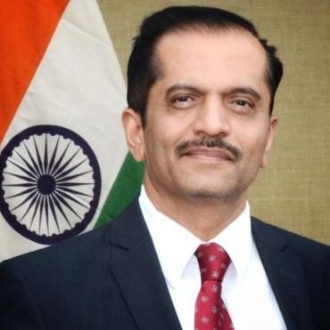
Investment arbitration plays a vital role in fostering conﬁdence, stability, and fairness in international economic relations. As cross- border investments continue to grow, effective dispute resolution mechanisms become essential to protect investor rights while upholding the sovereignty of host states. In this context, our initiative seeks to deepen understanding, encourage dialogue, and build capacity in the ﬁeld of investment arbitration. I warmly invite scholars,

Prof (Dr.) Bimal N Patel
practitioners, students, and stakeholders to actively participate, exchange insights, and contribute to shaping a more robust and equitable global investment environment. This platform will not only provide academic enrichment but also practical perspectives from global experts. It is a step toward building a future-ready community equipped to navigate the complexities of international investment law. I look forward to your enthusiastic participation and meaningful engagement in this important endeavour.

FROM THE DESK OF

PROFESSOR, PROGRAMME DIRECTOR UPPSALA UNIVERSITY MASTER'S PROGRAMME IN INVESTMENT TREATY ARBITRATION
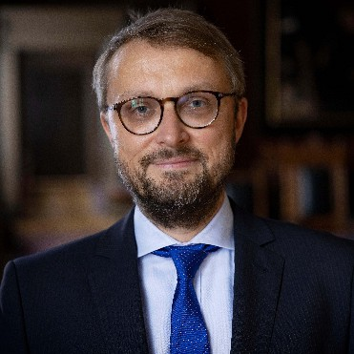
In today’s interconnected world, investment arbitration has emerged as a cornerstone of international economic governance. It offers a vital mechanism for resolving disputes, ensuring legal certainty, and promoting investor conﬁdence across borders. At a time when global investment ﬂows are shaping national economies, it is essential for academics, professionals, and future leaders to understand the nuances of this dynamic ﬁeld. This initiative reﬂects our commitment

Prof. (Dr.) Steffen Hindelang
to advancing specialized knowledge and fostering international collaboration. I wholeheartedly welcome all participants to engage deeply, learn actively, and contribute meaningfully to the evolving discourse on investment arbitration. Together, let us create a vibrant, informed, and solution-oriented community prepared to address the challenges and opportunities of global investment relations.



2


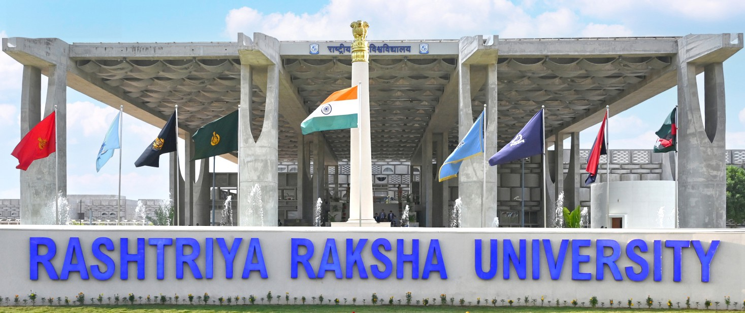

ABOUT RASHTRIYA RAKSHA UNIVERSITY
Established by the Parliament of India under Act No. 31 of 2020, Rashtriya Raksha University (RRU), an Institution of National Importance, Ministry of Home Affairs, Government of India, endeavors focus on highly professional security, strategic and police education, research and training through its qualiﬁed civilian, security and police faculty, committed human resource, motivated participants and students in an intellectually stimulating and professional disciplined environment with a world-wide network promoting sharing and exchange of ideas.

VISION OF RRU
To emerge as a premier Centre of Knowledge and as a University of National Importance, serving international and national stakeholders in pursuit of a peaceful, prosperous, stable, and conﬂict- resilient society. The University aims to advance India’s strategic and security culture through educational initiatives of defense, research, and training activities from security, police, allied services, civilian security, and others. Rashtriya Raksha University seeks to address contemporary and future security challenges by positioning the Nation as a capacity builder for internal and external security challenges while supporting the Ministry of Home Affairs, Government of India, and other stakeholders, with support from distinguished faculty from civilian, security, and police organizations, the University encourages a culture of merit and ethics, thereby offering services, knowledge, and education beyond traditional academic frameworks.

PRINCIPLES OF RRU
The university upholds principles of academic excellence, fostering innovative research, and promoting strategic awareness through inclusive training. It values teamwork, accountability, and a strong foundation of vision, commitment, integrity, and hard work. With a focus on care and concern, it nurtures individual potential and ethical growth. Emphasizing international cooperation, the university seeks to learn from and share best practices with national and global partners.
3

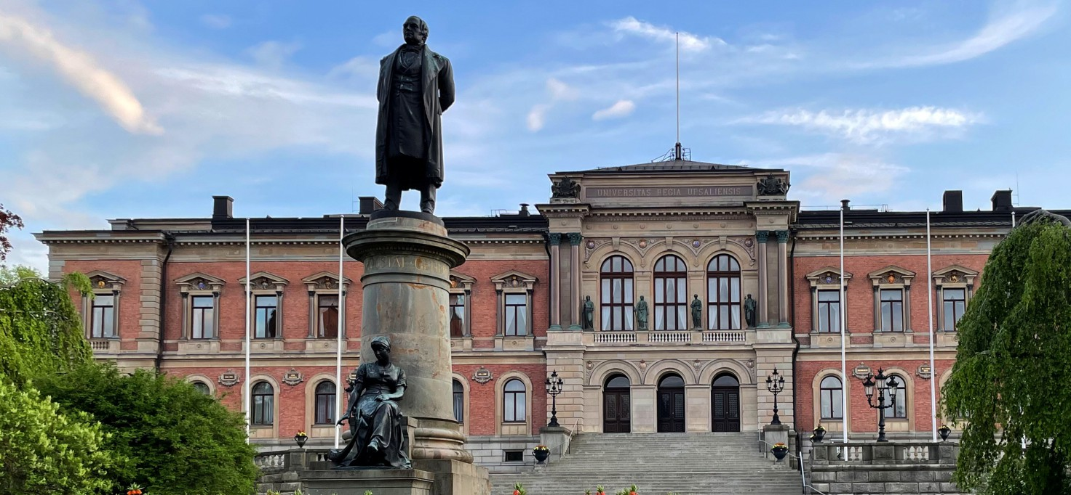

ABOUT UPPSALA UNIVERSITY
Uppsala University was founded in 1477. Today it is a strong, comprehensive research university ranked among the best in the world, with over 50,000 students and close to 6,000 researchers. Uppsala University’s mission is to gain and disseminate knowledge for the beneﬁt of humankind and for a better world.
The University is founded on the belief that investments in education and research are essential for creating a better future. It aims to provide an inspiring and well-functioning physical, social, and cultural environment that fosters learning and growth. Uppsala University contributes to development and innovation at both local and national levels and plays an active role in promoting sustainable social development. Collaboration with the wider community is an integral part of its research efforts, contributing directly or indirectly to solutions addressing society’s sustainability challenges. With a strong international outlook, the University builds global partnerships to advance knowledge across borders. It encourages critical thinking, creativity, and responsibility among students and researchers. The institution emphasizes academic freedom, ethical research practices, and inclusivity in all its endeavors. Uppsala University takes pride in its long-standing tradition of excellence, while constantly evolving to meet contemporary global challenges. Through this commitment, it aims to shape future leaders and contribute meaningfully to a just, knowledgeable, and sustainable world.

4


ABOUT THE FACILITATOR: CELIS INSTITUTE
The CELIS Institute is an independent, non-proﬁt research organization focused on improving the regulation of foreign investments in the context of security, public order, and competitiveness. As a leading forum for investment screening policy, it fosters dialogue among policymakers, academics, and the investment community. CELIS drives thought leadership and policy innovation in economic security, shaping discussions across Europe and democratic partners worldwide. Its ﬂagship event, the CELIS Forum on Investment Screening (CFIS), promotes best practices and builds a trusted expert community. The Institute also supports research publications and hosts an international fellowship program to prepare the next generation of investment policy experts.

ABOUT THE BOOTCAMP
Unlock the complexities of international investment law and economic security at the European–South Asian Investment Arbitration Bootcamp South Asia—an exclusive, intensive ﬁve- day program tailored for South Asian and European public ofﬁcials, in-house lawyers, and students dedicated to shaping the future of legal practice and economic policy across the region and beyond.
Hosted annually every August by the CELIS Institute gUG, Berlin, Germany, in collaboration with premier South Asian and European universities, this Bootcamp offers a dynamic hybrid experience combining expert lectures, practical workshops, and career-focused discussions both online and on-site. Participants will gain hands-on insights into the rapidly evolving landscape of investment arbitration, with a special focus in 2025 on economic security and the unique challenges faced by European and South Asian nations.

The Bootcamp is designed to build a vital bridge between Europe and South Asia, fostering the mutual exchange of expertise and creating meaningful value for both regions. By comparing diverse investment regimes and economic security strategies, participants will deepen their strategic understanding through rich, comparative learning. Guided by leading experts from both continents, the program delivers cutting-edge knowledge and best practices in a concise, high- impact format, equipping attendees with a comprehensive overview essential for success in today’s interconnected global economy.

5

KEY FEATURES
- Five-Day Bootcamp: An intensive, comprehensive program blending online and on-site
learning, hosted at Rashtriya Raksha University, India.
- Expert-Led Lectures: Gain insights from top practitioners and thought leaders specializing in investment arbitration, international law, and economic policy.
- Practical Sessions: Participate in interactive case studies and simulation exercises designed to build real-world skills in dispute resolution and economic security.
- Career Talks: Learn about diverse career pathways and opportunities from industry professionals active in investment arbitration and international law.
- Certiﬁcation of Attendance: Earn a prestigious certiﬁcate recognizing your enhanced expertise and successful participation in this critical ﬁeld.
- Networking Opportunities: Connect with emerging leaders and peers passionate about investment arbitration and economic security.
- Internship Opportunity: Gain hands-on experience by working with Rashtriya Raksha University or Professor (Dr.) Stefan Hindelang.

BOOTCAMP COURSE STRUCTURE
Module 1: GENERAL INTRODUCTION TO INTERNATIONAL INVESTMENT LAW
The ﬁrst module provides you with a general introduction to international arbitration. This module covers all the basic principles and rules of mainly commercial arbitration, which historically served as a role model for investment arbitration. You will discuss and analyze, for example, the arbitration agreement, the appointment of arbitrators, procedural issues, applicable law and enforcement of arbitral awards.
Module 2: SUBSTANTIVE STANDARDS OF PROTECTION
The second module will focus on the protection of foreign investments under public international law. The relevant sources relate to treaties (i.e. bilateral and multilateral investment protection treaties) and customary international law. One important aspect of this module is treaty interpretation based on the Vienna Convention on the Law of Treaties.

6

Module 3: DISPUTE SETTLEMENT IN MODERN INTERNATIONAL INVESTMENT LAW
The third module will illuminate the traditions of the Investor-State Dispute Settlement and provide an outlook on Intra-EU Investment Arbitration (CJEU's Achmea decision, C-284/16) and its repercussions.
Module 4: ECONOMIC SECURITY MEASURES AND THEIR IMPACT ON INVESTMENT LAW
This module explores how evolving national and regional economic security measures are reshaping the landscape of international investment law. It examines investment screening mechanisms in jurisdictions like the EU, USA, and India, and the growing emphasis on state sovereignty and regulatory space. Key topics include national security exceptions in BITs, recent arbitration jurisprudence, and CELIS-led policy innovations. Participants will analyze real-world disputes and learn how economic security concerns increasingly inﬂuence investor rights and ISDS frameworks.
Module 5: CAREERS IN INTERNATIONAL INVESTMENT LAW
This module offers practical guidance on building a career in international investment law across law ﬁrms, governments, academia, and international organizations. Participants will gain insights into key skills, educational pathways, and global opportunities, including fellowships and internships with institutions like Uppsala University and the CELIS Institute.
Bonus session: Careers in International Investment Law Learning methodology:
- Lectures
- Seminars and practical exercises
- Panel discussions with practitioners and policy specialists
- Career-related insights

7

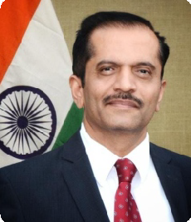
ESTEEMED FACULTIES

Prof (Dr.) Bimal N Patel Vice Chancellor,
Rashtriya Raksha University

- Member, International Law Commission.
- Member, National Security Advisory Board.
- Member, Financial Sector Regulatory Appointments Search Committee (FSRASC).

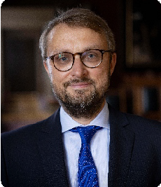
Professor Dr. Steffen Hindelang

- Professor of International Investment and Trade Law at Uppsala University in Sweden.
- Executive Director of the CELIS Institute, an independent, non-proﬁt, non-partisan research enterprise dedicated to promoting better regulation of foreign investment in the context of security, public order and competitiveness.
- Advised the EU, European governments as well as companies on investment review regimes, international investment disputes, and international organisations on the reform of the current international investment law regime.
- Repeatedly invited by the European Parliament's INTA Committee to prepare studies on the development of the EU's Common Commercial Policy.
- Frequently acts as an expert advisor before international tribunals and national courts and has served as an ICSID arbitrator.

8

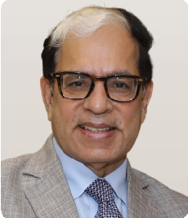
Justice Arjan Kumar Sikri

- Justice Arjan Kumar Sikri currently serves as an International Judge at the Singapore International Commercial Court (SICC), and is involved in legal opinion work, arbitration, and mediation both in India and international.
- He consistently topped his class in legal education, earning multiple postgraduate diplomas and degrees including LL.B., LL.M., and two honorary doctorates in law.
- Starting practice in 1977, he specialized in diverse legal areas and rose through the judiciary ranks to become a Supreme Court Judge, retiring in 2019 as the senior-most puisne judge.
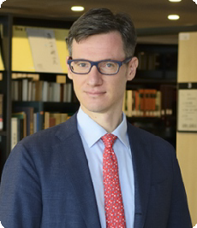
- He authored over 4,700 judgments and was recognized globally for his impact on Intellectual Property Law, alongside active participation in teaching, writing, and presenting scholarly legal work.

Prof. Giorgio Fabio Colombo

- Full Professor of Comparative Law at Ca' Foscari University Venice (Italy).
- Former Director of the Research Unit "Decolonizing Arbitration", Nagoya University (Japan).
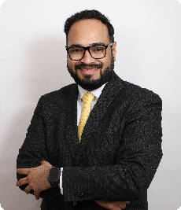
- Attorney-at-law (Bar of Milan) and arbitrator in the lists of EDAC, HKIAC, JCAA, KCAB Int'l, MIAC, TAI.

Shravan Yammanur

- Partner in Dentons Link Legal’s Dispute Resolution practice in Delhi, where he focuses on International Arbitration, Public International Law, Trade Law, and Litigation.
- Advocate-on-Record of the Supreme Court of India and an International Adjunct Faculty Member of the Uppsala University Master's Programme in Investment Treaty Arbitration.
- Has worked in the Government of India for several years advising on foreign investment and trade issues as a member of India’s negotiating team for Investment Treaties and Investment Chapters of Free Trade Agreements.

9

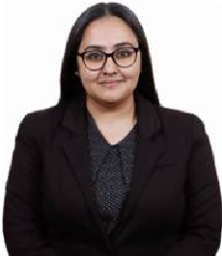
Ramya Raman

- Associate Partner, Investor-State Arbitrations, P&A Law Ofﬁces, New Delhi, India focusing on representations of sovereign clients in investor-state arbitrations.
- Former Legal Consultant, International Investment Treaties and Framework Division of the Department of Economic Affairs, Ministry of Finance, Government of India, New Delhi.

- Former Private sector experience as Legal Executive in Wipro Limited, Bengaluru, India.

Argha Kumar Jena

- Principal Associate (International Dispute Resolution and Litigation), DMD Advocates.
- Ex-Senior Legal Consultant (International Investment and Trade Law), Department of Economic Affairs, Ministry of Finance, India.
- Research Coordinator of the Task Force on Investment Contracts and Awards at Roma Tre- UNIDROIT Centre for Transnational Commercial Law and International Arbitration.
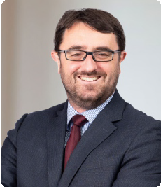
- Inter-disciplinary Ph.D. (Rome) on International Law and Economics with a full scholarship from the Italian Ministry of Higher Education and LL.M. (Berlin) on International Dispute Resolution.

Lucas Bastin KC

- Lucas is a barrister at Essex Court Chambers in London, and has extensive multi-jurisdictional experience, in all forms of international disputes. He is very experienced in international investment arbitration, international commercial arbitration and litigation with an international dimension. He also appears before international law fora.
- In addition to his connections with Uppsala University, Lucas is Adjunct Professor of Public International Law at Pepperdine University and Lecturer at King’s College London in Investment Arbitration.

10

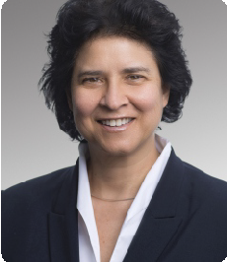
Patricia Nacimiento

- Patricia Nacimiento, Dr. iur., leads the German dispute resolution team and the EMEA international arbitration team at Herbert Smith Freehills. She specializes in Public International Law and investment disputes, with over 25 years of experience.
- She has extensive experience as counsel under the rules of numerous arbitration institutions, including ICC, ICSID, SCC, CIETAC, DIS, LCIA, ICDR, Swiss Chamber of Commerce, Indian Council of Arbitration, and the Danish Institution of Arbitration, as well as in ad hoc proceedings. Appointed by the German government to the ICSID list of arbitrators since 2007, she also leads multi- national teams in arbitration-related court proceedings.

- Patricia is a native German speaker and is ﬂuent in English, Spanish, French, and Italian. She teaches investment disputes at the Universities of Berlin, Heidelberg, and Saarland, and excels as an editor of leading commentaries on Arbitration in Germany and the New York Convention. She is recognized globally as a leading disputes expert in renowned rankings and directories.

Prof. Marcin Kałduński

- Vice-Deputy of the International and European Law Department of the Prokuratoria (Poland).
- Acts as counsel in investment and commercial arbitration (ICSID, UNCITRAL, SCC and ICC Rules)
- Professor of International Law at the Nicolas Copernicus University (Poland).
- Former Visiting Fellow in the British Institute of International and Comparative Law and the University of Cambridge (LCIL).

11

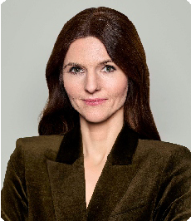
Ass. Prof. Veronika Korom

- Assistant professor of international business law and arbitration at ESSEC Business School in Paris and an afﬁliated partner at the dispute resolution boutique PARAGON Advocacy in Vienna.
- Acts as counsel in commercial and investment arbitration, with a focus on cases involving EU law and matters related to the CEE region, and serves as arbitrator in commercial disputes.
- Admitted to practice law in England & Wales, France, and Hungary.
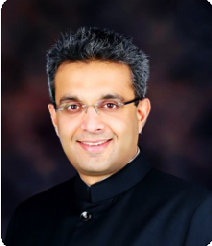
- Member of the ICC International Court of Arbitration for Hungary, sits on the Board of the Vienna International Arbitral Centre (VIAC), and serves as the President of the Hungarian Arbitration Association (HAA).

Shreyas Jayasimha

- Has been providing legal services and solutions to clients across various sectors and jurisdictions for over 23 years.
- Has co-founded Aarna Law in Bengaluru, New Delhi and Mumbai and Simha Law, Singapore.

- Has represented the Republic of India in signiﬁcant investment treaty disputes and has taught courses on ISDS at various universities in India and international arbitration at KEIO University Japan.

Lorena Fatás Pérez

- State Lawyer - Deputy in the Department of International Arbitration in the General State Administration.

12


Floor Doppen

- Political scientist, currently ﬁnalising her PhD on the Political Economy of Investment Screening at the University of Antwerp.
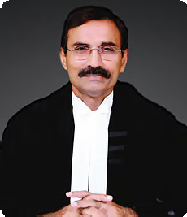
- Managing Program Associate at CELIS, in charge of organising the CELIS Thought Leaders Program.

Justice L. Nageswara Rao

- Did his B.Com., B.L., from Nagarjuna University, Guntur, Andhra Pradesh.
- Enrolled as an Advocate on 29.07.1982 at Bar Council of Andhra Pradesh; from July, 1982 to January, 1984 practiced at the District Court, Guntur, Andhra Pradesh; from January, 1985 to December, 1994 practiced at the High Court of Andhra Pradesh, at Hyderabad.
- From January 1995 to May, 2016 practiced at the Supreme Court of India.
- Designated as a Senior Advocate by the Andhra Pradesh High Court in December, 2000
- Served as Additional Solicitor General of India from August 2003 to May, 2004 and again from 26.08.2013 to 18.12.2014
- Appointed as a Judge of the Supreme Court of India on 13.05.2016

- Retired on 07.06.2022

Ass. Prof. Sai Ramani Garimella

- Associate Professor, Faculty of Legal Studies, South Asian University, New Delhi, India.
- Visiting Senior Research Associate, Center for Private International Law, University of Johannesburg University, South Africa.
- Team Coordinator, Working Group on International Investment Contracts, UNIDROIT Rome.
- Industrial Training Consultancy with the KAF Foundation wing of the PHD Chambers of Commerce, New Delhi.
13

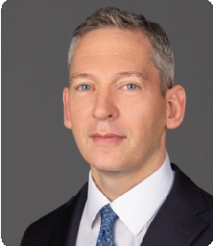
John Kabealo

- Partner at Kirkland & Ellis LLP.
- Throughout his career, John has been involved in complex transactions that require comprehensive diligence, careful structuring and nuanced purchase agreement negotiation, where he draws heavily on his foundation as a transactional attorney ; advised clients on several hundred transactions involving CFIUS and Defense Security Service issues, including more than one hundred that have been formally ﬁled with CFIUS; negotiated national security agreements, security control agreements, special security agreements and proxy agreements with the U.S. government in some of the largest and most complex transactions in the technology, telecommunications, defense, energy and ﬁnancial sectors.
- Former Associate at Skadden, Arps, Slate, Meagher & Flom; Founder Kabealo PLLC.
- Education: Princeton University; University of Virginia School of Law.

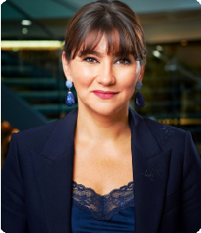
Ioana Knoll-Tudor

- Dr. Ioana Knoll-Tudor is a partner in the Paris ofﬁce of Addleshaw Goddard. She has over 15 years of experience, having represented and advised clients in numerous international and domestic arbitrations (both institutional and ad hoc), with a particular focus on the energy, construction, competition & distribution and post-M&A sectors. She also acts in post-arbitration proceedings (annulment and enforcement of arbitral awards) before French courts.
- Ioana regularly seats as arbitrator (chair, co-arbitrator, sole arbitrator) before major arbitral institutions, both international (such as ICC, ICSID and VIAC) and regional (CICA-CCIR, CCIJ), including with States and State-owned parties. She is the ﬁrst Romanian nationality arbitrator appointed on an ICSID panel (ICSID Case No. ARB/19/30).
- Her book « The Fair and Equitable Treatment Standard in International Foreign Investment Law » (Oxford University Press, 2008) is a reference in the ﬁeld of international arbitration, with a second edition expecting publication by 2025.
- Ioana was appointed member of the ICC Court of Arbitration for the 2024-2027 mandate, representing Romania and she is a Board Member of the SCC Arbitration Institute.

14


Prof. Giorgio Sacerdoti

- Prof. Sacerdoti is emeritus professor at Bocconi University in Milan, Italy, where he has been professor of international law and European Law (Jean Monnet Chair, 2004) focusing on international economic relations, trade and investment law, international business transactions, arbitration and dispute settlement.
- Graduate of the Milano University Law School, LLM Columbia Law School, Ph.D (libero docente) in international Law; visiting professor in several universities in a number of countries, course holder at the Hague Academy of International Law, Senior Braudel Fellow at the European University Institute (Florence).
- Extensive experience in international dispute settlement: he has been a judge at the WTO Appellate Body from 2001 to 2009 (chairman 2006-2007), trade arbitrator in bilateral disputes, frequent arbitrators in investment disputes at ICSID (on which roster he has been appointed for more than 30 years) and other institutions.
- He is the author of more than 200 hundred publications in his ﬁelds of specialization; his latest book: “International Trade and Investment Dispute Settlement. From Rise to Crisi and Reform.” (with Niall Moran) Routledge has been just published in May 2025.

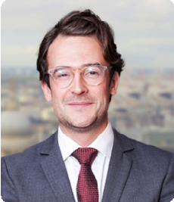
Joel Dahlquist

- International Arbitration Advisor at Arnold & Porter Kaye Scholer LLP.
- Adjunct Professor at the London School of Economics and Political Science.
- Former Managing Associate at Arbitration Chambers – Hong Kong / London / New York.
- Former Doctoral Candidate and Junior Lecturer at Uppsala University.

15

FOR FURTHER DETAILS PLEASE CONTACT
Dr. Niharika Raizada
+91 95544 36499; ap16.sclml@rru.ac.in
Ms. Helene Schramm
+49 1577 1751133; ra004@steffenhindelang.de
Mr. Harshit Singh
+91 95725 46365; ro1.rcil@rru.ac.in

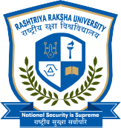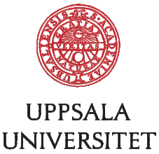

RASHTRIYA RAKSHA UNIVERSITY
Lavad - Dehgam - 382305 Gandhinagar, Gujarat, INDIA Website : www.rru.ac.in
Uppsala universitet, Box 256, 751 05 Uppsala Sweden
Website : www.uu.se/en
CELIS UNIVERSITY
CELIS Institute gUG (haftungsbeschränkt) Grolmanstraße 32, 10623 Berlin
Website : https://www.celis.institute


KNOWLEDGE PARTNER


